

**Design Changes**

**and**

**Rationale**

**for**

**Library information appication**

**Version: 1.0**

**Date: 18/06/09**

**20143692 강경석**

**20144103 조유성**

**20145026 김상범**

**20141043 양준호**

**20146110 문태현**

**20143583 김기환**

Table of Contents

Index

[Library information appliciation] 0

Version 1.0 1

June 9, 2018 2

1. Login screen 3

2. User screen 4

3. Administrator Screen 5

4. booklist Screen 6

1. **Login Screen**
2. Version 1.0

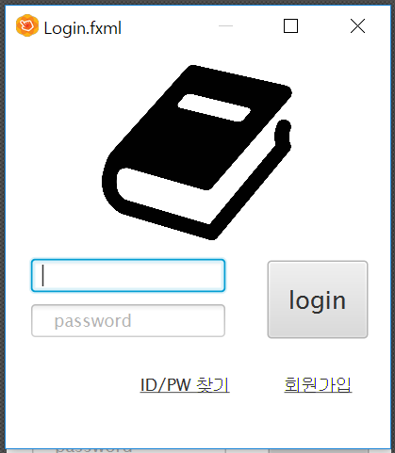

1. Version 2.0

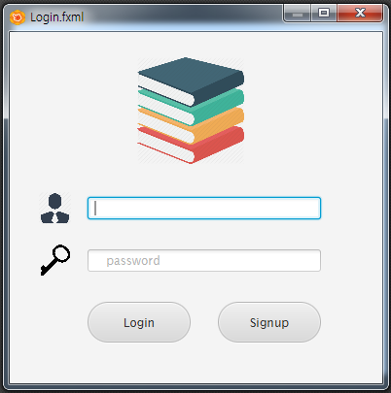

*Change Rationale)*

The first reason for graphic change of login screen is to make the interfaces more simple and clear. Secondly, we have decided to delete the function of finding ID/PW. Also, we wanted to develop the aesthetic sense of GUI.

1. **User Screen**
2. Version 1.0

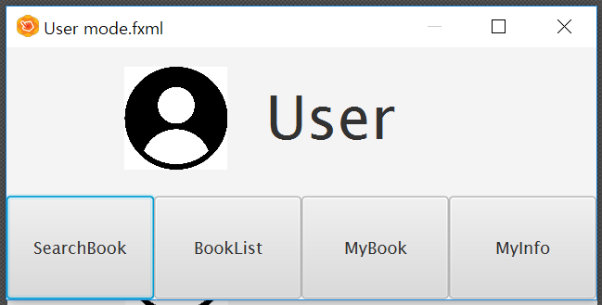

1. Version 2.0

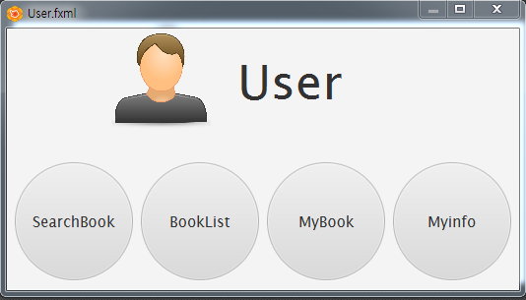

*Change Rationale)*

The main reason for the change of the user screen’s graphic is to raise the aesthetic sense and make the screen more simple and clear.

1. **Administrator Screen**
2. Version 1.0



1. Version 2.0



*Change Rationale)*

The main reason for the change of the user screen’s graphic is to raise the aesthetic sense and make the screen more simple and clear.

1. **Booklist Screen**
2. Version 1.0

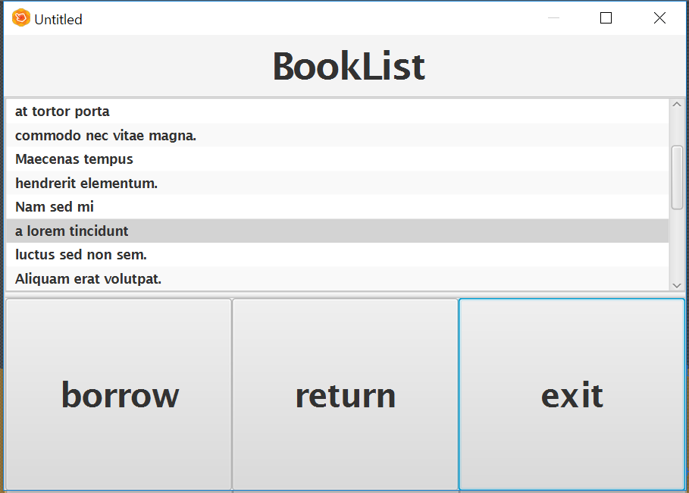

1. Version 2.0

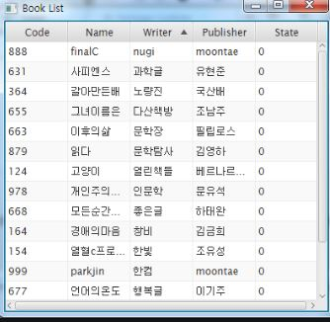

Change Rationale) Client can see a lot of information of books so our team focused on efficiency.